**Computer System Architecture Project – Phase IV**

**Machine Simulation Basic Design Document**

**By Priyanka More, Phani Gadepalli, Akshay Thombre, Siddarth Gandhi**

* **Use Case Diagram:**

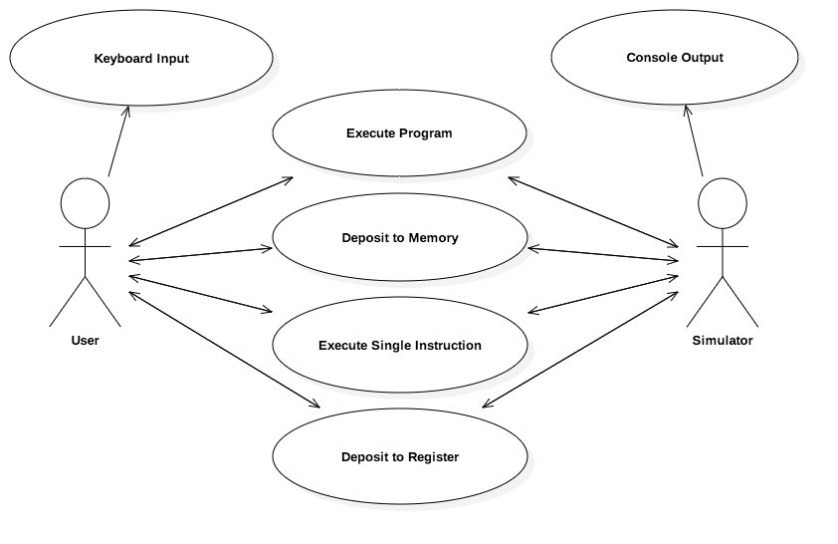

* **Class Diagram:**

